# AINT151 – Web Game Technologies

**Freya Beggs**

**Student ID: 10581619**

**GIT Repository:** [**https://github.com/flbeggs/FreyaBeggs**](https://github.com/flbeggs/FreyaBeggs)

**Live Game:** [**https://flbeggs.github.io/**](https://flbeggs.github.io/)(Different to the files in the other repository. Submitting player name had to be removed because a 405 error kept occurring. Likely because it linked to a separate webpage.)

## Proposal

For this assessment a hypertext fiction minigame had to be created, using HTML, CSS and JavaScript. My plan was to make a game with multiple endings, depending on what choices the player made, rather than having a linear path. Initial planning for the game was done by making a diagram of the narrative branches (shown below).

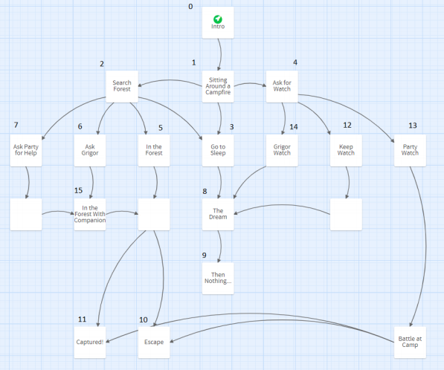

The game would then be created as a website using this diagram as a guide, making changes where appropriate.

## Peer Review

Greg Rogers: “”

Alisha Wilton: ””

Other Comments: “Could do with being more concise. Many slides could have been condensed into one.”

“The multiple endings are a nice touch, just need to be fleshed out more.”

“Could have made it so text or options change depending on what companion you chose.”